TECHNOLOGY ARCHITECTURE

TRAIN DATA

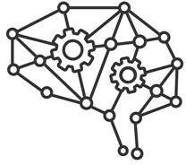

IMAGE PROCESSING

TEST DATA

DATASET

USER



SIGN LANGUAGE

Application Developed by FLASH UI

MODEL

TEXT / VOICE

TEAM ID:PNT2022TMID28501